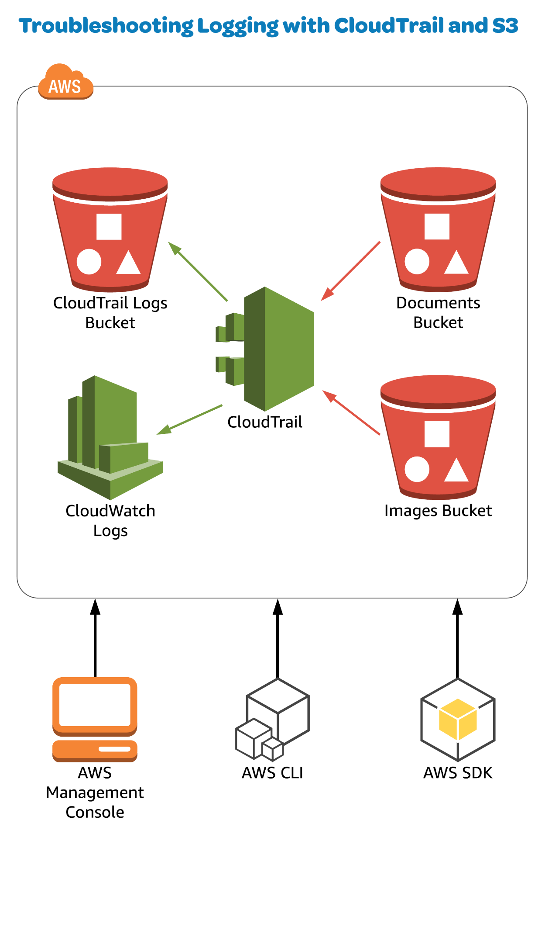

Introduction

In this lab, we'll solve a real-world scenario in which CloudTrail is not properly logging to CloudWatch Logs. We will configure CloudTrail to capture object uploads into two S3 buckets and log the events to CloudWatch Logs.

Log in to the AWS Management Console using the credentials provided on the lab instructions page.

Enable CloudTrail Logging

1. From the AWS Management Console, navigate to the CloudTrail service.
2. Click **Trails** in the left sidebar.
3. Click the name of the trail to open it.
4. At the top right of the configuration page, toggle the **Logging** switch to *On*.

Configure CloudWatch Logs

1. Scroll down to *CloudWatch Logs*, and click **Configure**.
2. Click **Continue**.
3. Click the arrow next to **View Details** to expand the details menu.
4. In the *Role Summary* menu, click into the **IAM Role** field and select the pre-configured role from the dropdown.
5. Click **Allow**.

Enable Object Logging for Both Buckets

Enable Object Logging for the Images Bucket

1. Scroll down to *Data events*, and observe that the Images bucket is configured for object-level logging.
2. Open the S3 service in a new browser tab.
3. Click the Images bucket to open it, then click the **Properties** tab.
4. Object-level logging should be enabled.
5. Click the **Overview** tab.
6. Click **Upload**.
7. Click **Add files**, and choose a file.
8. Click **Next** three times, then **Upload**.
9. Navigate to the CloudWatch service, and click **Logs** in the left sidebar.
10. Under *Log Groups*, click the name of the log group to open it.
11. Click **Search Log Group**.
12. Wait about a minute for the events to appear.
13. In the *Filter events* text box at the top of the page, enter the following:

{$.eventName = "PutObject"}

1. Wait a few moments for the events to appear.

Enable Object Logging for the Documents Bucket

1. Go back to the S3 Management Console.
2. Click the name of the Documents bucket to open it.
3. In the *Overview* tab, click **Upload**.
4. Click **Add files**.
5. Choose a file to upload.
6. Click **Next** three times, then **Upload**.
7. Go back to the CloudWatch Management Console, and observe that no putObject event is logged.
8. Go back to the S3 Management Console, and click the **Properties** tab.
9. Click the **Object-level logging** box.
10. Note that this is one way to enable object-level logging.
11. Go back to the CloudTrail Management Console.
12. Click **Trails** in the left sidebar.
13. Click the name of our trail to open it.
14. Under *Data events*, notice that only the Images bucket has been set up for object-level logging.
15. Click the pencil icon on the right side of the *Data events* header.
16. Click **+ Add S3 bucket**.
17. Click into the *Bucket name* field, and select the Documents bucket from the dropdown.
18. Click **Save**.
19. Go back to the S3 Management Console.
20. Click the **Overview** tab, then **Upload**.
21. Click **Add files**.
22. Choose a file to upload.
23. Click **Next** three times, then **Upload**.
24. Click the **Properties** tab, and observe that object-level logging is now enabled.
25. Go back to the CloudWatch Management Console, and click **Logs** in the left sidebar.
26. Click the name of the log group to open it.
27. Click **Search Log Group**.
28. In the *Filter events* field, enter the following:

{$.eventName = "PutObject"}

1. Wait a few moments for the events to appear.